

Contact us….

**Admin team:**

email: [christchurch1843@gmail.com](mailto:christchurch1843@gmail.com)

**Parish Office** 01903 215343

**Usual Office Hours:**

**Wednesday 10am – noon: Thursday 2pm – 4pm**

**Editor: Carol Warrington**

.

**Worship for March in Christ Church**

**2nd 10.30am Holy Communion**

**6pm Evensong**

**5th 12:30pm Holy Communion for Ash Wednesday**

**9th 10.30am Morning Prayer**

**13th 10.30am Thursday BCP Holy Communion**

**16th 10.30am Holy Communion**

**6pm Evensong**

**23rd 10.30am Morning Prayer**

**27th 10.30am Thursday BCP Holy Communion**

**30th 10.30am Holy Communion, Mothering Sunday**

**Worship for April in Christ Church**

**6th 10.30am Holy Communion**

**6pm Evensong**

**10th 10.30am Thursday BCP Holy Communion**

**13th 10.30am Morning Prayer for Palm Sunday**

**17th 7pm Maundy Thursday Holy Communion**

**18th 2pm Good Friday Service of Reflection**

**20th 10.30am Holy Communion for Easter Day**

**24th 10.30am Thursday BCP Holy Communion**

**27th 10.30am Morning Prayer followed by APCM**

**Christ Church Members support**



We are a Christian organisation that has been supporting families worldwide for nearly 150 years. Started by our founder [**Mary Sumner**](https://en.wikipedia.org/wiki/Mary_Sumner) in 1876 in her local parish, we have grown into an international charity with over 4 million members in 83 countries.

As a Christian membership charity, we demonstrate our faith in action. This happens as we work towards **ending poverty, ending inequality ending injustice.** Our members work at grassroots level around the world. They bring hope and practical support to millions of people every year through parenting, literacy and community development programmes.

**What does the central charity do?**

We campaign at local, national and international levels to bring about real change for gender equality and for the rights of women and girls.

We also support our members within the UK and across the world with a vast collection of practical and spiritual [**resources**](https://www.mothersunion.org/resources). In addition, we produce regular publications like Connected and the Prayer Diary to keep members in Britain and Ireland informed and up-to-date with what's happening around the corner and around the world.

Everyday, we broadcast Midday Prayers live on our [**Facebook page**](https://www.facebook.com/MothersUnion/) at 12pm GMT. We believe that the power of prayer is transformational and it is the heartbeat of who we are and what we do.

We also run a [**monthly e-Newsletter**](https://r1.dotdigital-pages.com/p/1I8Y-G0K/sign-up-to-the-mothers-union-mailing-list)[**,**](https://mothersuniononline.org/p/1I8Y-G0K/newsletter) featuring a round-up of current events and stories from across the movement.

Despite our name, we are an inclusive organisation and we are very proud to have a growing number of men who have joined us.

You're invited to[**join us in our journey and be a part of something life-changing.**](https://www.mothersunion.org/get-involved/join-us-today)

Mothers' Union in the Diocese of Chichester was created in 1891 and has 40 branches throughout East and West Sussex with over 795 members. Here in Sussex we believe in praying with our feet moving, and our prayer with purpose underpins all our activities.

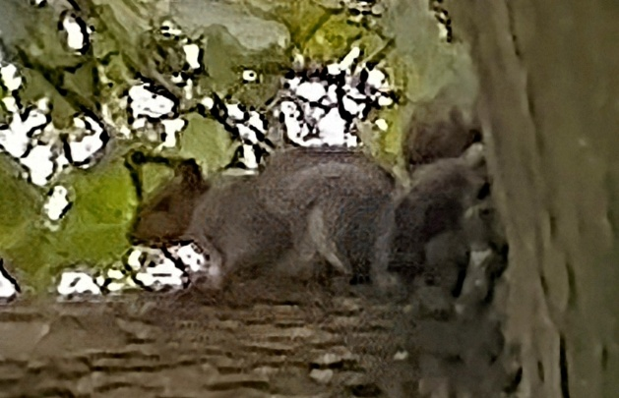

**Wildlife at Christ Church – Grey Squirrels**

I often see grey squirrels bolting up the trees in our churchyard as I approach. Although an invasive, non-native species, it’s not their fault that they have replaced the native red squirrel in large parts of the country. Introduced by humans in the nineteenth century, they outcompete their British cousins and carry squirrel pox, a disease which only affects the red variety.

They can become very tame. There are many videos online showing how ingenious these creatures can be when obtaining treats from bird tables and feeders, with obstacle courses designed to outwit them. Hiding supplies of food such as acorns in autumn, they spread plantlife when they fail to retrieve the cache. Grey squirrels make a nest, called a 'drey' out of twigs, leaves and strips of bark in the fork of a branch, high up in the tree canopy. Females may have two litters of three to four young a year.

The grey squirrel has a silver-grey coat, with a brownish face and feet, and pale underside. It has a characteristically bushy tail. It is distinguished from the red squirrel by its larger size, grey fur, and smaller ears without tufts. However, grey squirrels can vary in colour, with some appearing slightly ginger.

<https://www.wildlifetrusts.org>

My favourite squirrel fact is that their Greek name means ‘shadow with a tail’!



**Christ Church Members support**

Several members of our church family have been busily knitting teddy bears for the seafarers at the Mission to Seafarers. We still have some patterns if any other knitters would like to have a go. They’re very simple to make! A big thank you to all contributors and also to Lorraine who has made individual bags for each one.

Dorothy

[**https://www.missiontoseafarers.org/at-church/knitting**](https://www.missiontoseafarers.org/at-church/knitting) **is the link to their website, complete with downloads for knitting patterns.**

Renewal and Transformation.

**John 2 verses 1 – 11**

At a country wedding at the time of Jesus, it was possible that the whole village or community was present. The celebrations could have lasted nearly a week, and it was crucial to ensure that enough food and drink had been prepared for every eventuality.

The responsibility for the provision of wine at a wedding belonged with the bridegroom. If the wine ran out, this would not just have been seen as unfortunate but a deep matter of shame to the bridegroom and his family. It is always worth noting that whatever else is going on, Jesus rescues the honour of a man in his community. On the threshold of his new life in marriage, he would not have wanted to live with the shame and dishonour this would have brought him.

Jesus has been invited – although no reason for his presence is given and similarly his mother is there, but we are not told ‘why.’ Yet when the wine runs out it is she who addresses Jesus as if he will be able to do something. We do not know why this might be the case as we are also told after the event that this was ‘the first sign’ that Jesus performed. Did she sense or know something?

What do we make of Jesus’ response – ‘Woman, what concern is that to you or me?’ The greeting in first century context is not as brusque as it sounds; but Jesus is clear – he is not going to be directed by her, whatever the relationship between them. His hand will not be forced; ‘My hour has not yet come;’ he will work on his own terms. Despite this, notice the faith of Mary when she says to the servants, ‘Do whatever he tells you.”

John is then specific. There were six stone water jars standing nearby. These contained water kept for Jewish rituals of cleansing and purification from defilement. (There was much in the Jewish Law that could cause defilement). This is likely an authentic detail from John. Clay jars could get more easily smashed or broken or could become tainted and need to be destroyed. This was not the case with stone. The jars would be expensive to make and impossible to lift but were more economical!

They are also big. Each one holds 20-30 gallons (that is 90 – 136 litres each). We do not know if these are approximations or reflects that there were different sized jars. But the servants are told to fill them to the brim – it meant that a container would need to be plunged in to get anything out.

If we assume that each jar held 20 gallons, that is the equivalent of 540 litre bottles of wine. Even if the whole village was there, that is a lot of wine on top of everything else they have had to drink already.

So, what might we notice from this account?

There is something about **quality** when Jesus is present. It is not that water is a bad thing; we do not know that the wine which had been served was no good (the steward simply says that it was not as good and had run out). What is supplied by Jesus is the absolute best. It is not to write off what has gone before but rather that this is special and different.

With reference to Israel’s history is not that the Law has been no good or the prophets irrelevant, simply that Jesus now embodies the richest and fullest expression of life with God and in God. People still need purifying and cleansing – but now in a completely new and full and final way. To say ‘My hour has not yet come’ is a bold statement at the very beginning of his ministry; the hour may not have yet fully come, but when it comes it will be the fullest expression of the love of God and in contrast everything else pales into insignificance.

This also speaks of **abundance.** There is so much wine – just as later there will be so much bread and so many fish. This Jesus brings more abundantly, beyond our wildest dreams the love and grace, mercy and goodness, forgiveness, and peace of God; they pour out of him and never run dry. Does it feel now, as it did at the wedding feast that we receive the abundant and full life that only Jesus can bring? In fact, what does abundant life with Jesus look like today? Is it our experience and our prayer that Jesus would continue to transform us individually and as a church?

Maybe you would like to pray again the Collect for 19th January 2025:

Almighty God, in Christ you make all things new, transform the poverty of our nature by the riches of your grace, and in the renewal of our lives, make known your heavenly glory.

It has been said:

‘It is not too much to say that the main business of the Christian life is to go through the world, turning its water into wine.’

What water might you or we seek to change into wine in the coming week?

And at the end of the passage, we are told by John that Jesus ‘revealed his glory’ – although we do not actually know who beyond Mary and the servants knew exactly what had happened! But here in the everyday world of a country wedding, Jesus’ glory is revealed and made known.

**And how in this world, our world, do we make that glory known?**

*The Venerable Chris Skilton*

*A sermon preached at Christ Church Worthing on 19th January 2025.*

***Do you have a joke, favourite quote, photograph, article, poem or picture that you would like to share with us?***

**Email** [**christchurch1843@gmail.com**](mailto:christchurch1843@gmail.com)

**Three people are debating about who has the oldest profession. The doctor says,**

**“God put Adam to sleep while he removed the rib to make Eve. That’s surgery, therefore medicine is the oldest.”**

**The architect pipes up, “Before that, God made order out of chaos. That’s my case for my calling.”**

**The MP smiles and replies, “Where do you think the chaos came from?”**

**Joker Windmills: Part One**

Alex Vincent

These joker mills were created by taking photographs of five Sussex windmills, scenery and a few other things and then they were cut out and stuck together. The photographs were then scanned digitally. Below is a list of the various types of mills and the items used to make them.

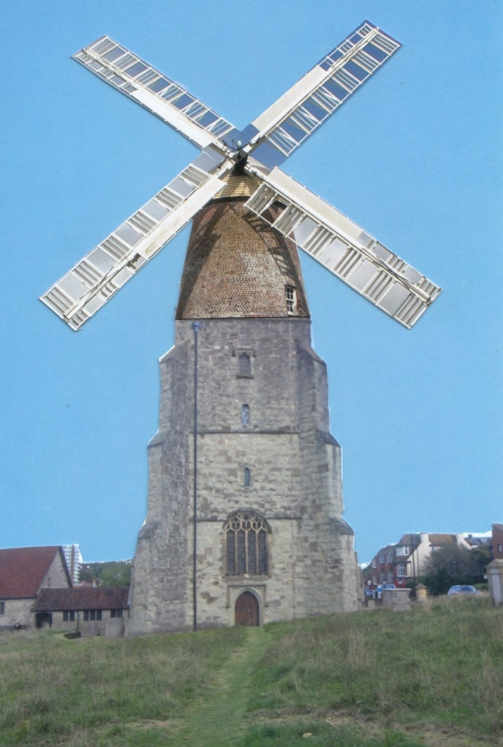

**Tower Mill.** The sails and top part of Polegate Windmill and the tower of Eastbourne church.



**Smock Mill.** The sails of West Blatchington Windmill, a smock in the mill museum atWest Blatchington and field at Highdown, Ferring.



**Watermill.** Sails of West Blatchington Windmill, spring water bottle and the Ferring Rife, Ferring.



**Tide Mill.** Sails ofHigh SalvingtonWindmill and groyne on Worthing Beach.

*More next time!*

***WORDS CAN MAKE A DIFFERENCE***

A smartly dressed young man was walking along a street in New York City. He saw a homeless man sitting on the side of the road, begging for money.

In front of him was an empty coconut bowl and a cardboard sign. Written on the sign were the words, “BLIND PLEASE HELP”.

The young man noticed that even though it was the rush hour and many people were walking by, not a single person was giving him any money. The young man felt sorry that no one was helping the homeless man. He picked up the cardboard sign and took out a thick marker from his pocket. He turned the cardboard over and rewrote the sign.

The homeless man was aware that someone was there writing something on the cardboard, but didn’t say anything. The young man returned the sign and went on his way.

In just a few minutes, the empty coconut bowl started to fill up with money. Tears filled the man’s eyes as he heard the unmistakable sound of money raining into his bowl.

He stopped a stranger and asked, “What’s written on the cardboard?”

The stranger replied, "IT’S A BEAUTIFUL DAY, BUT I CAN’T SEE IT.”

*Written by ALAN BARNES*

**CHRIST CHURCH EVENTS 2025**

**Easter Egg Hunt** following Holy Communion on 20th April

**Cream & Savoury Teas** 17th May 2025

**Annual Autumn Fayre** 13th September 10:30-12:30

**Fish and Chip Lunch** 18th October at 12 noon

**Christmas Mini Market** Saturday 22nd November 2024 10.30am - 12.30pm.

**‘Celebration of Life’ Service** 23rd November at 10:30am

**Bring and Eat ‘Here comes Christmas’ Celebration** Sunday 8th December after service

**Carol Service** Sunday 14th December at 4pm

****Christ Church Concerts 2025**

**18th March *–* Catalina Jazz Band**

**8th April –Sylvia Akagi and Peter Golden *-*** classical, traditional, blues and original music, singing,

with Guitar and Flute

**6th May *–* John Collins,**Organ and **Paul Gregory,** Guitar

***–* A Tribute to Richard Bowen**

**17th June *-* The Brighton Guitar Quartet**

**8th July *-* Yoko Ono *-*** Piano

**12th August *–* South Downs Folk Singers**

**23rd September *–* John Collins *-*** Organist

**21st October *-* Evelyn Harrison, Beatrice Sales *&***

**Zhanna Kemp-Dashkovskaya**

Piano, Clarinet, Flute and Viola

**4th November *–* Rob Campkin**and **James Buckham** -violin and piano

**2nd December *–* Angelina Kopyrina –**pianist

*12th August –*

*South Downs Folk Singers*

Created with TheTeachersCorner.net Word Search Maker

**Spring Wordsearch**

|  |  |  |  |  |  |  |  |  |  |  |  |  |  |  |  |  |  |  |  |  |  |  |  |  |  |  |  |  |  |  |  |  |  |  |  |  |  |  |  |  |  |  |  |  |  |  |  |  |  |  |  |  |  |  |  |  |  |  |  |  |  |  |  |  |  |  |  |  |  |  |  |  |  |  |  |  |  |  |  |  |  |  |  |  |  |  |  |  |  |  |  |  |  |  |  |  |  |  |  |  |  |  |  |  |  |  |  |  |  |  |  |  |  |  |  |  |  |  |  |  |  |  |  |  |  |  |  |  |  |  |  |  |  |  |  |  |  |  |  |  |  |  |  |  |  |  |  |  |  |  |  |  |  |  |  |  |  |  |  |  |  |  |  |  |  |  |  |  |  |  |  |  |  |  |  |  |  |  |  |  |  |  |  |  |  |  |  |  |  |  |  |  |  |  |  |  |  |  |  |  |  |  |  |  |  |  |  |  |  |  |  |  |  |  |  |  |  |  |  |  |  |  |  |  |  |  |  |  |  |  |  |  |  |  |  |  |  |  |  |  |  |  |  |  |  |  |  |  |  |  |  |  |  |  |  |  |  |  |  |  |  |  |  |  |  |  |  |  |  |  |  |  |  |  |  |  |  |  |  |  |  |  |  |  |  |  |  |  |  |  |  |  |  |  |  |  |  |  |  |  |  |  |  |  |  |  |  |  |  |  |  |  |  |  |  |  |  |  |  |  |  |  |  |  |  |  |  |  |  |  |  |  |  |  |  |  |  |  |  |  |  |  |  |  |  |  |  |  |  |  |  |  |  |  |  |  |  |  |  |  |  |  |  |  |  |  |  |  |  |  |  |  |  |  |  |  |  |  |  |  |  |  |  |  |  |  |  |  |  |  |  |  |  |  |  |  |  |  |  |  |
| --- | --- | --- | --- | --- | --- | --- | --- | --- | --- | --- | --- | --- | --- | --- | --- | --- | --- | --- | --- | --- | --- | --- | --- | --- | --- | --- | --- | --- | --- | --- | --- | --- | --- | --- | --- | --- | --- | --- | --- | --- | --- | --- | --- | --- | --- | --- | --- | --- | --- | --- | --- | --- | --- | --- | --- | --- | --- | --- | --- | --- | --- | --- | --- | --- | --- | --- | --- | --- | --- | --- | --- | --- | --- | --- | --- | --- | --- | --- | --- | --- | --- | --- | --- | --- | --- | --- | --- | --- | --- | --- | --- | --- | --- | --- | --- | --- | --- | --- | --- | --- | --- | --- | --- | --- | --- | --- | --- | --- | --- | --- | --- | --- | --- | --- | --- | --- | --- | --- | --- | --- | --- | --- | --- | --- | --- | --- | --- | --- | --- | --- | --- | --- | --- | --- | --- | --- | --- | --- | --- | --- | --- | --- | --- | --- | --- | --- | --- | --- | --- | --- | --- | --- | --- | --- | --- | --- | --- | --- | --- | --- | --- | --- | --- | --- | --- | --- | --- | --- | --- | --- | --- | --- | --- | --- | --- | --- | --- | --- | --- | --- | --- | --- | --- | --- | --- | --- | --- | --- | --- | --- | --- | --- | --- | --- | --- | --- | --- | --- | --- | --- | --- | --- | --- | --- | --- | --- | --- | --- | --- | --- | --- | --- | --- | --- | --- | --- | --- | --- | --- | --- | --- | --- | --- | --- | --- | --- | --- | --- | --- | --- | --- | --- | --- | --- | --- | --- | --- | --- | --- | --- | --- | --- | --- | --- | --- | --- | --- | --- | --- | --- | --- | --- | --- | --- | --- | --- | --- | --- | --- | --- | --- | --- | --- | --- | --- | --- | --- | --- | --- | --- | --- | --- | --- | --- | --- | --- | --- | --- | --- | --- | --- | --- | --- | --- | --- | --- | --- | --- | --- | --- | --- | --- | --- | --- | --- | --- | --- | --- | --- | --- | --- | --- | --- | --- | --- | --- | --- | --- | --- | --- | --- | --- | --- | --- | --- | --- | --- | --- | --- | --- | --- | --- | --- | --- | --- | --- | --- | --- | --- | --- | --- | --- | --- | --- | --- | --- | --- | --- | --- | --- | --- | --- | --- | --- | --- | --- | --- | --- | --- | --- | --- | --- | --- | --- | --- | --- | --- | --- | --- | --- | --- | --- | --- | --- | --- | --- | --- | --- | --- | --- | --- | --- | --- | --- | --- | --- | --- | --- | --- | --- | --- | --- | --- | --- | --- | --- | --- | --- | --- | --- | --- | --- | --- | --- | --- | --- | --- | --- | --- | --- |
| |  |  |  |  |  |  |  |  |  |  |  |  |  |  |  |  |  |  |  |  | | --- | --- | --- | --- | --- | --- | --- | --- | --- | --- | --- | --- | --- | --- | --- | --- | --- | --- | --- | --- | | M | B | Z | C | Z | S | C | T | S | S | E | R | T | T | A | M | Q | B | U | S | | A | T | R | H | R | G | O | Z | A | E | Z | W | L | A | V | I | T | S | E | F | | B | V | Z | I | C | Y | J | F | C | E | W | B | O | S | S | O | R | R | P | V | | L | N | S | D | F | G | S | G | L | Y | G | Q | G | R | E | E | N | E | R | Y | | O | I | H | U | N | O | I | T | C | E | R | R | U | S | E | R | K | T | E | Y | | S | C | H | C | C | D | V | X | A | V | D | H | O | D | W | Y | W | S | Q | E | | S | W | R | K | G | O | Q | D | P | L | I | G | I | E | X | R | B | A | U | X | | O | O | S | L | O | S | R | O | A | H | F | F | L | T | G | B | J | E | I | D | | M | B | B | I | O | R | B | C | T | F | C | I | W | I | U | T | I | K | N | M | | U | N | R | N | D | E | U | C | K | X | F | V | E | T | N | F | S | S | O | X | | X | W | K | G | F | W | M | Z | X | G | S | O | T | U | R | G | L | D | X | A | | Z | A | H | S | R | O | B | D | B | L | U | E | D | E | N | L | V | S | H | P | | D | R | F | O | I | H | L | R | W | E | R | Y | N | I | E | M | E | U | G | R | | N | M | Z | H | D | S | E | A | V | F | G | E | R | B | L | K | X | Y | A | I | | Z | E | Y | X | A | C | B | N | L | J | W | E | E | S | A | L | O | X | R | L | | B | R | A | H | Y | J | E | I | Q | A | H | U | Q | C | Z | A | W | P | D | L | | X | Q | D | S | L | S | E | V | L | T | L | W | N | R | L | M | E | A | E | U | | K | S | Y | A | X | S | S | W | O | B | X | A | H | C | A | B | L | J | N | U | | D | W | A | G | B | E | L | M | H | V | P | H | L | B | Q | S | N | D | U | G | | J | U | M | H | C | R | A | M | S | T | P | A | T | R | I | C | K | R | Y | V | |
| |  |  |  | | --- | --- | --- | | APRIL  APRIL FOOL | BLOSSOM | BLUEBELLS | | BUMBLEBEES | BUTTERFLIES | CROCUS | | CRYSTAL | DAFFODIL | DUCKLINGS | | EASTER | EQUINOX | FESTIVAL | | FLEDGLING | GARDEN | GOOD FRIDAY | | GREENERY | LAMBS | MARCH | | MATTRESS | MAY DAY | MOTHERING | | PANCAKES | RENEWAL | RESURRECTION | | SHOWERS | ST GEORGE | ST PATRICK | | WARMER |  |  | |

***You have my sincere apologies!***

**Archaeology/History Walks in Worthing for 2025**

*Alex Vincent*

I am running a series of archaeology/history walks for Christ Church in Worthing once a month between June and August. These will take place in the morning on the second Wednesday of the month. If rained out, then the walk will take place on the next Wednesday . We start at 10.00am and end up at Christ Church for the Coffee Morning. The walks for this year are listed below:

**May 14** - Old Worthing Street, cottages and pond. Meet outside Guildbourne Centre.

**June 11** - Worthing Libraries. Meet outside Stagecoach office on seafront.

**July 9** - Site of ancient sea cliffs and hills. Meet at east end of Worthing Pier.

Any enquiries my telephone number is 07753282714.

Email [alexeclipsing@gmail.com](mailto:alexeclipsing@gmail.com) via Worthing Library.

**Chichester 950**

*from 1075 to the present day*

**To mark our 950th anniversary, we are delighted to present:**

***Religion, Rebellion & Reformation***

**an exhibition sharing the story of the Christian faith in Sussex, revealed through people, events and treasures, from 1075 to the present day.**

The exhibition, which runs from 14th February - 15th November 2025, features fascinating artefacts from across the Diocese of Chichester, spanning East and West Sussex. Each object reveals remarkable moments and people from history.

Highlights include:

* Bejewelled rings and intricately decorated staffs and croziers owned and worn by the influential bishops of the Middle Ages.
* Comparing a delicate bronze Medieval crucifix, unearthed in a churchyard in Coombes, with a simple wooden cross fashioned from duck board by a WWI soldier in the trenches.
* A pocket-sized Bible donated by the Sussex Regiment, containing a pressed flower from Macedonia, where its owner served on the front line.
* The inspiring story of a group of wealthy and well-connected women who defied societal norms to help establish the first Anglican sisterhood, The Society of St Margaret, in 1854. Read their journals to explore how their tireless work brought lifesaving care to the sick and destitute in East Grinstead and beyond.
* Meeting Reginald Peacock, a Bishop of Chichester and the first theologian to write in English—a bold act that ultimately led to his condemnation as a heretic.

These and many other fascinating artefacts will allow visitors to discover nine centuries of hidden histories and to reflect on the enduring role of faith during times of hardship and change.

*Religion, Rebellion & Reformation* has been curated by the Cathedral’s Canon Treasurer, the Reverend Canon Vanessa Baron, Visitor Experience Manager Rebecca Lewry-Gray, and designed by Chichester-based design team [StudioMoo](https://www.studiomoo.me/).

**We’re open for coffee and a chat every Tuesday and Wednesday morning from 10.30 till 12noon**

**On Thursday afternoons between 2.30 and 4pm, we open for “The Crafty Club” coffee and natter sessions, when you can bring anything you love doing, knitting, crochet, sewing, drawing, colouring… anything.**

**Enjoy chatting over a cuppa, or you can just pop in to talk with friends old and new, have a tea or coffee and biscuits and catch up.**

**Maybe you would just appreciate sitting in the church in quiet reflection… whatever you like, you are always welcome!**

And finally . . .

Q: What is the difference between a clown and a man going through a mid-life crisis?

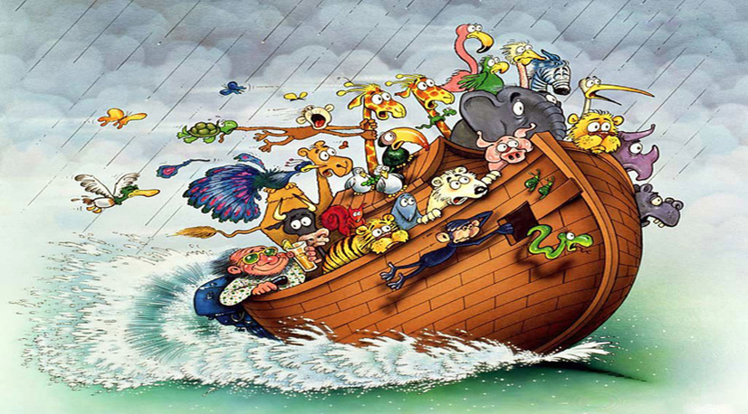A: The clown *knows* he’s dressed completely ridiculously.

Why was Noah the best businessman in the Bible?

*He floated his stock whilst everyone else was being liquidated*